Future Location Of Class “A” Office Space
Available In 2005!!!

Route 207 & LaGrange Road
In The Beautiful Town Of Hamptonburgh

Up To Three Thousand sq./ft. Available First Phase
Up To Six Thousand sq./ft. Available Second Phase

*Three Minutes From Downtown Goshen (Same Road)*
*Five Minutes From Orange County Airport (Same Road)*
*Fifteen Minutes From Stewart Int’l. Airport (Same Road)*
*Five Minutes From Crystal Run Medical Center*
*Two Minutes From Metro North Train Station*

Call “RHP Enterprises Corp.” At: 1-888-919-2263

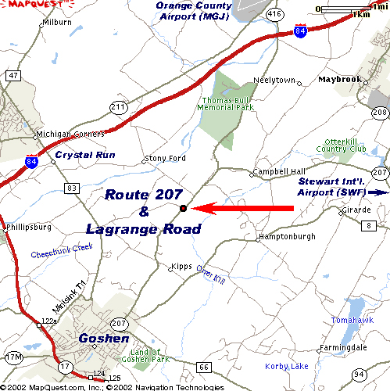
Or Visit Our Web Site At:
http://rhpec.com

